Investigation 6. The Japan-China War Unofficially ’31-45, Officially ’37-45.
Cross out the answers you think are wrong and underline/circle the deliberate mistakes.
- In July 1937 Japanese troops provoked local Chinese troops into a fight on the Ibn Battuta/Marco Polo/Christopher Columbus bridge outside Beijing.
- Claiming the Chinese had killed their badgers/fired on them the Japanese launched an attack on army bases around Beijing.
- The Japanese captured Hainan/Kiaochow/Shanghai, China’s most important port then advanced up the Yangzi/Yellow/Xiang River to capture to capital Brijing/Nanjing.
- Chiang Kaishek was forced to retreat to Sichuan where he set up a new wartime capital in the city of Zunyi/Chingqing/Wuhan.
- From ‘38 to ‘44 the Japanese did not make further advances in China. They had run out of badgers/boarders/manpower. They occupied large cities, important railways, airfields, ports and roads.
- In the north they concentrated on trying to destroy Chiang’s wartime government in Zunyi/Chingqing/Wuhan bombing it so hard it became known as ‘the most bombarded city in the world.’
- In ’41 the United Stated declared war on Japan/Germany/Britain after Japan attacked the American Naval Base at Ruby Harbour in the Pacific.
- An immediate result of this was the arrival in China of American supplies along the Thai/Mongol/Burma Road.
- The high-water mark of Japanese expansion came in April ’44 when, advancing north from Wuhan they captured the city of Nanjing/Changsha.
- August 6th, the Americans used an atomic bomb to destroy Hiroshima, August 8th the Malay Red Army declared war on Japan and invaded Manchuria. On the 9th a second bomb was dropped on ____________
- In the eight official years of war between China dna Japan 2/4/6 million Chinese were killed and a further sixty were made homeless.
- For millions of people it was a war of appalling cruelty. Japanese forces acted with great savagery right from the start of the war. Looting rape, torture, murder and needless destruction took place in nearly every area they occupied. There is no mistake in this sentence.
- During the war, from ’37 to ’40 the Communist/Nationalist fighters gradually moved eastwards from their base at Huangpu/Yanan/Guangzhou. They began an offensive called the Hundred Regiment Battle in which they attacked Japan’s road/railway communications.
- To deal with the threat the Japanese began the For All Campaign.
- By 1945 the Communists controlled 16/18/21 ‘liberation areas’.
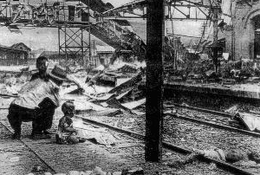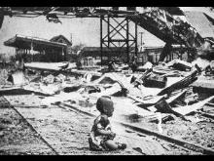
If you haven’t done as well as you’d like re-read pages 20 & 21. Read pages 22 and 23 for the next quiz!
Images sourced at -
http://globalogue.org/forums/read.php?9,4622,4622
Suggested figure for research – Iris Chang.

