A Guide to Answering
Paper 2 Questions

Rule No. 1 – Don’t Freak Out!

- Cross-Referencing
How far do these sources agree?
Explain your answer using details of the source.

Main tip – Get the big picture! Obviously you’ll read the sources and highlight details that agree/disagree but try and pick up the overall tone of each source so you can compare that as well. Maybe one source is more positive than the other, maybe one source is a judgement while the other is just a commentary, maybe one source is direct while the other offers implications.

Most common mistake – Omission is not the same as disagreement! Just because one source doesn’t mention something doesn’t mean that it disagrees with a source which does. Identifying omissions is not enough – it’s Level 2 stuff.

Level 1 – REPEAT (1)
Source A says………………... Source B says…………………

Level 2 – IDENTIFY OMISSIONS (2)
Source A says nothing about ………………..but B does.

Level 3 – DESCRIBE AGREEMENT OR DISAGREEMENT (3-4)
Both sources show………………………...
Both sources mention……………………………………..
or
The sources disagree in their overall opinion of………………………………..
They also give different impressions of ………………………….

Level 4 – BOTH OF THE ABOVE (4-5)

Level 5 – ADD ‘OVERALL’ STATEMENT (5-6/7)
Add the following to the two paragraphs above…..
Overall, B solidly supports A in emphasizing t………………………
but the tone of B is different to A; B gives a………………………………

Plan of Attack; Highlight agreements in one colour, disagreements in another.
- Two/three sentences on Agreements, including two details; one from each source.
- Two/three sentences on Disagreements, including two details; one from each source.
- ‘Overall…..’ sentence.

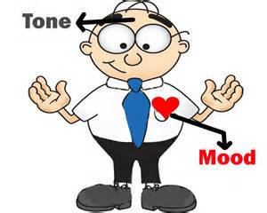

Don’t forget to look at tone!
- Publication
Why was x published?
Explain your answer using details of the source and your own knowledge.

Main tip – Write around the source/s or cartoon/s. Use a highlighter.

Most common mistake – Is to misinterpret the source

Level 1 – DESCRIBE CONTENT (1)
Source X shows…………

Level 2 – DESCRIBE PROVENANCE (2)
Source X is ……………… (British/German) etc

Level 3-4 – EXPLAIN THE MESSAGE OF THE SOURCE (3-5)
Make connections
In the source I see…………… this might mean that……………… (do this three times)

Level 5 – EXPLAIN THE CONTEXT OF THE SOURCE (6)
What was going on in History at the time the source was written?

Level 6 – GIVE DETAIL BY EXAMINATION OF AUDIENCE/CONTEXT (7)
The source was published in…………………..
It is likely in this context that author wanted………………..
Their audience would have been……………………………

Plan of Attack; Write around the cartoons. Show ‘+’ and ‘-‘ points.
- STATE THE OBVIOUS. What’s the content of the sources and what form do they take? Where from?
- EXPLAIN. Is the content different because of the purpose/form of the source?
- DETAIL = AUDIENCE & CONTEXT.

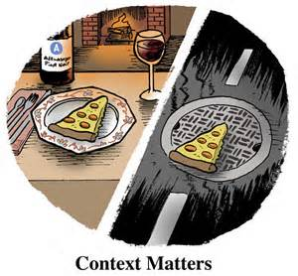

Think about Context!

- Cross-Referencing for Proof!
Does Source X prove that Source Y is wrong/unreliable
Explain your answer using details of the source and your own knowledge.

Main tip – Look for compatibility. Even if the sources sound totally different could they possibly work together.

Most common mistake – ONLY examining the provenance and ignoring differences in content or the other way around.

Level 1 – DESCRIBE CONTENT (1)
The sources both talk about…..

Level 2 – DESCRIBE PROVENANCE (2-3)
The sources both talk about…..
Source X is from ……… and Source D is from………

Level 3 – COMPARE CONTENT (3-4)
Source X states…………….
Source Y states…………….
The tone of X i…………………, the tone of Y is……………………………

Level 4 – EXPLAIN DIFFERENCES (5-6)
The tone may be different because Source X is ……………
The tone of Y can be explained by………………….(looking at the provenance perhaps).

Level 5 – GIVE DETAIL BY CROSS-REFERENCE AND ANSWER THE QUESTION! (7-8)
In one source…………(detail)……….. but in the other source…………(detail)…………
The sources could/could not work together because……………………..
So X does/does not make Y wrong/unreliable.

Plan of Attack; Highlight similarities and differences.
- STATE THE OBVIOUS. What’s the content of the sources and what form do they take?
- COMPARE CONTENT. What are the similarities/differences?
- EXPLAIN. Is the content different because of the purpose/form of the source?
- DETAIL = CROSS-REFERENCE. Use details in the source to help you say if the sources can or cannot work together.

Make sure you actually
Answer the Question!
- Study all the sources
How far do they support an argument?
Explain your answer using details of the sources and your own knowledge.

Main tip – Draw a ‘Y’, ‘N’ ven diagram. Sources which ‘yes’ support the statement in one circle, sources which ‘no’ don’t support the statement in another and those which support both in the overlap.

Most common mistake – Is to not judge ‘How far’ or recognise that some sources might fit BOTH columns.

Level 1 – Misinterprets the Sources (1-3)
Level 2 – Uses the sources well but doesn’t see that some of the sources offer evidence for both sides. (4-6)
Level 3 - Uses the sources well but AND CAN see that some of the sources offer evidence for both sides. Discusses HOW FAR the sources support the statement overall.(7-10)

Up to 2 bonus marks for EVALUATION OF SOURCES.
Discussion of HOW FAR A PARTICULAR source is worth using and to what extent it supports the statement.

Plan of Attack; Draw a ven-diagram.
- Go through the sources one at a time. For each source state evidence for the statement AND evidence which does not support the statement if there is any.
- For at least two of the sources write an in-depth paragraph discussing how reliable the evidence is.
- Don’t forget to give a summing up statement.

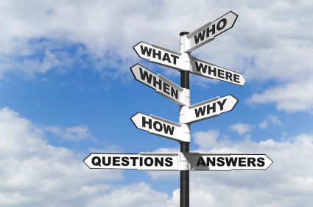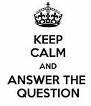

Make sure you actually
Answer the Question!

- A Basic Pattern for ALL Source Questions…….

PURPOSE – State what’s going on in History around the time the source was written/drawn. Can context help you explain the author’s/artist’s purpose?

Remember C.O.P. Content, Origin, Purpose.

A cartoon about the peace negotiations published in a British newspaper in 1919
ORIGIN – State what’s going on immediately around the source? What’s its provenance? Who published it? When? Why?
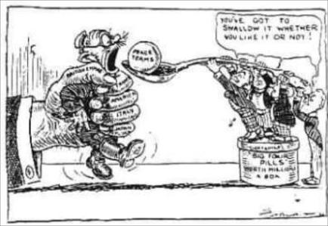

CONTENT – State the Obvious. The source tells me/shows……. This may mean that…………..

